CHIP DRIVE
USE of ENCRYPTED USB STICK

CHIP Drive was developed as a resource for facilitators and their participants who found access to the internet difficult.

CHIP Drive can be used in the delivery of either face to face programs or online programs where the participant and facilitator view the videos together before taking part in the group discussion.

CHIP Drive can be used in any Mac or Windows PC computer. However the videos will only play while the CHIP drive is inserted into the computer. Materials on CHIP Drive cannot be saved to any computer or transferred to another drive.

Process
- Insert USB stick into any USB slot on your computer
- Use Windows Explorer or Apple finder to navigate to the USB stick.
- Double click on the Start.exe file.

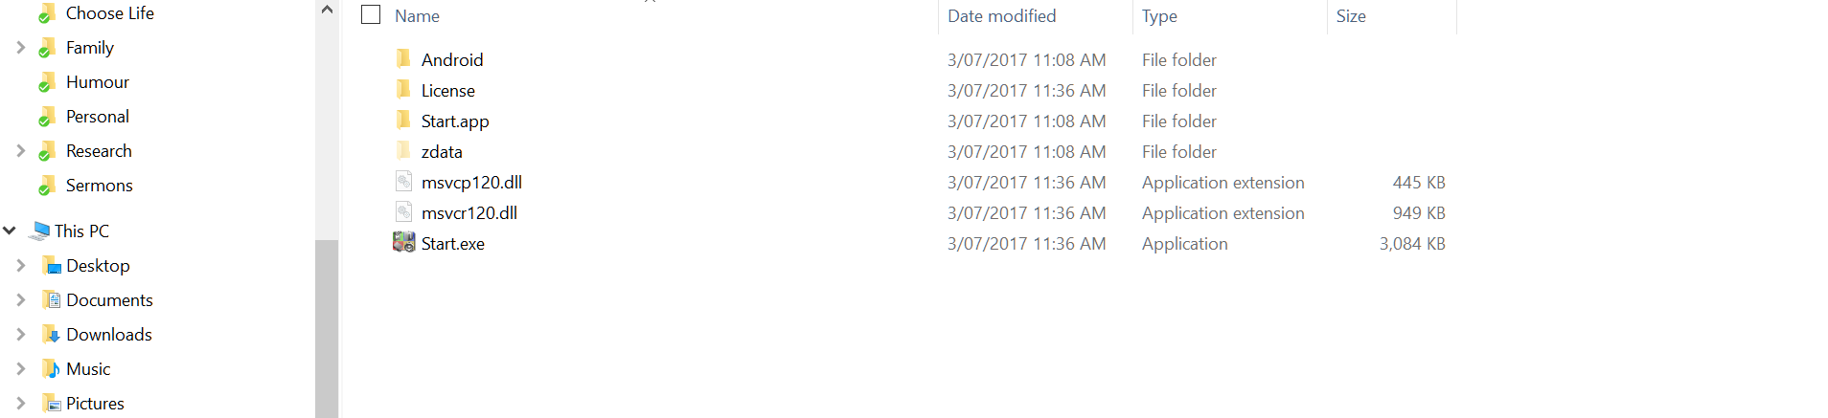
- This will open up the Flux MENU. Click on the session that you want to play.
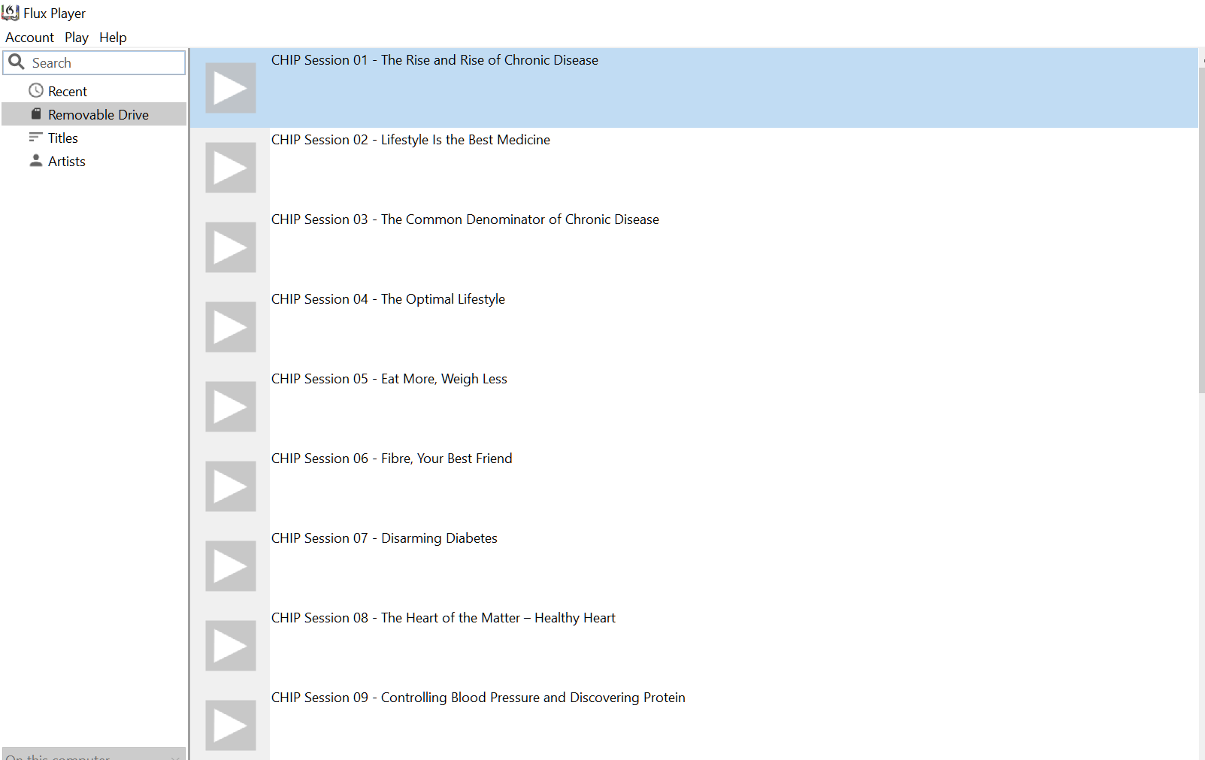

- This will open up the Flax PLAYER. The icon to toggle full-screen mode is in the bottom right-hand corner.

- You can pause, stop, fast forward, rewind or drag the dot on the line to any point in the video to play the video where you want.

Ordering:
CHIP Drives expire after a set period. The expiry date is displayed in the top left of the screen when viewing the program icons. CHIP drives can be returned for resetting of the expiry date or a new Drive can be ordered. Please check costs for both options at the time of ordering.

Please allow 4 weeks for ordering and testing your CHIP Drive. To place an order contact info@chiphealth.org.au or +61 (02) 98473367

(Rev. 29.6.20)

