Lifestyle Medicine Institute, LLC
Loma Linda, California

Issues a Certificate of Accomplishment to

Participant name
who has successfully completed all requirements of the
Complete Health Improvement Program (CHIP).
CHIP is a lifestyle education program designed to teach individuals how to take
charge of their health by emphasizing the causes, prevention, and reversal of common Western diseases.

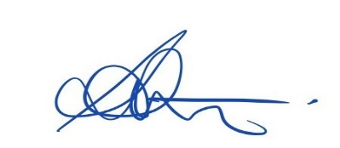

Sharon Stevenson Facilitator name
Director LMI CHIP Australia

